Nancy L. Meyer: Press Kit

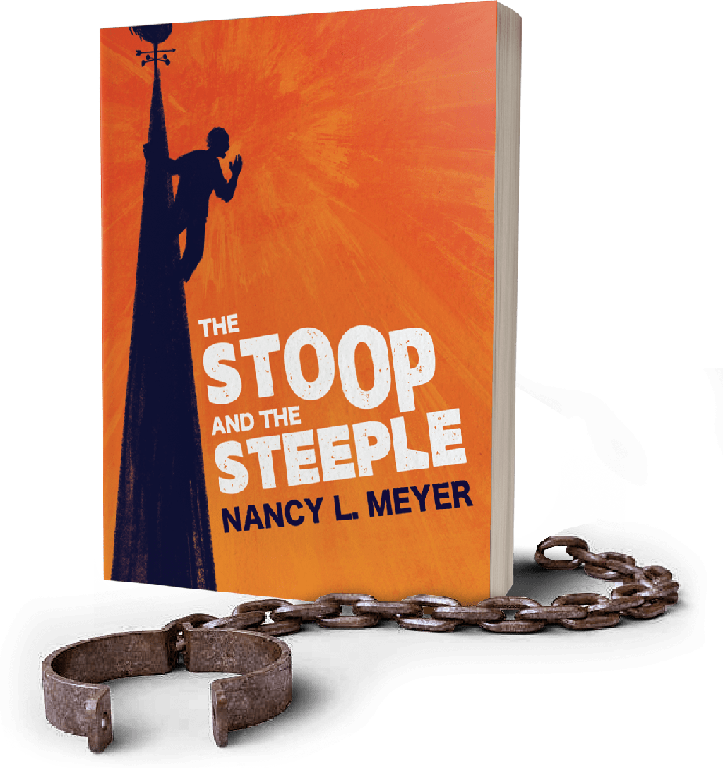
The Stoop and The Steeple
Nancy L. Meyer
SEPTEMBER 2024
98 pp. / 7.5x9.25
$15.00 / paperback / ISBN 979-8-9880696-4-5
$20.41 Canadian / £11.41 UK
Kindle E-book: Amazon / ASIN B0DFMVMY5C

Web & Social media:
https://nancylmeyer.com
https://www.instagram.com/nancylmeyerpoet
https://www.facebook.com/NancylMeyerpoet

Description:

Three lives, intertwined, two centuries apart. An exploration of the complexities of race and power at an intimate level.
In The Stoop and the Steeple, Nancy Meyer directs an uncompromising lens at the fifteen years she spent with Mel, a Jamaican artist she met on a New York stoop, and faces the memory of Zebulon a man her ancestors enslaved. A man who climbed a steeple and crowed. Was it for freedom? We will never know, but the mystery of this image drives the speaker into unexpected discoveries.
Nancy and Mel married, raised a child, divorced. Zebulon ran away, was captured, and sold. Through lyric and narrative poetry, Nancy tells a personal story against the backdrop of 18th century documents and her eighth-great-grandmother’s diary. The poems create a prism, each one catches a different light and expands our vision. Of a mixed-race marriage, of the dreams that twisted into white supremacy, of the stories families tell and those they keep secret.
The Stoop and the Steeple invites readers to explore their own responses, to look with clarity and compassion at the idealism, ruptures, pain and love across generations and in modern America. Together with its reader guide, the book is a unique portal for deeper study by educators, social justice groups and individuals.

Short pitch:

The Stoop and The Steeple by Nancy L. Meyer weaves reflections on the speaker’s first marriage to a Jamaican with the discovery that her colonial New England ancestors were enslavers. Narrative and lyric poetry plus responses to historical documents and an18th century family diary tell an intimate story of power and race, idealism and ruptures across generations.

Praise for The Stoop And The Steeple

The Stoop and the Steeple is ground-breaking, provocative writing. I know of no other text with a speaking agent who is a white woman in our current era choosing to delve into her family’s lineage as slave-owners. Nancy L. Meyer calls forth the ghosts in her speaker’s past and challenges us to find their relevance today. She intersperses astutely imagistic poetry with fluidly interwoven narratives.
In “Text Fragment: Zebulon on the Steeple,” the poem begins “I can’t stop seeing Zebulon on the steeple, hearing his call singe the sky. I can’t stop knowing my own ancestors enslaved him.” The poem uses images to express feelings rather than simplify them with explanation. Following a trail of veiled mysteries, each page of this book opens us to entirely new ways to perceive all that has come before. It is one of the most important books I’ve read this year. One I will return to again and again.
—Rusty Morrison, author of RISK, Editor of Omnidawn

In The Stoop and the Steeple, poet Nancy L. Meyer offers a gripping, immersive narrative in verse, one that traces a family history, a personal history, and a history of our nation’s slave-holding beginnings. In this braided story, a couple tries to reconcile the color divide between them from the 1965 Selma to Montgomery March to the shores of Jamaica and San Francisco. With the speaker’s late discovery of her own family’s slave-holding legacy, the story of one such slave continues to haunt her own. “How do you spin apart,” the speaker asks, her own life spinning out of control. How Meyer bravely pulls it back together is a marvel you won’t want to miss, a “history scrolled on all our skins,” no matter the color.
—Sally Ashton, author Listening to Mars and The Behaviour of Clocks

What a moving and beautiful collection. I almost typed “enthralling” (which seems a problematic word in this enslavement context). Once I started reading, I needed to keep on to the end—it is a very rare thing for a collection of poems to have that sense of urgent, developing arc, as well as all the pleasures of formal variety and rich surprising imagery and language. It is a wonderful and brave book, alive with seeking.
—Dr. Karen Sanchez-Eppler, L. Stanton Williams '41 Professor of American Studies and English at Amherst College

Short biography:

“Writing helps me expose disparate fragments and make new wholes.”
Nancy L Meyer, she/her, intrepid cyclist and grandmother of five lives in the unceded Ohlone lands of San Francisco. She has published in nine anthologies and over 50 journals including: Tupelo Quarterly, Feral, Museum of Americana, and the Colorado, Laurel, McNeese, and Sugar House Reviews. Recipient of a Hedgebrook Residency.
Her first full-length collection, The Stoop and The Steeple, was published in Fall 2024 by Frog On The Moon.

Nancy is available for…

Solo or group readings, interviews and workshops in which she offers a selection of poems as portals to questions such as:
- How do you connect or separate from others in cross-racial, cross-cultural relationships?
- What family stories do you NOT tell?
- What do you think our 8th great-grandchildren would say about us today?
An experienced group facilitator, Nancy creates an atmosphere of play, curiosity and safety in which there are no right answers and members choose their level of participation.

Book availability:

Signed copies are available by contacting Nancy via www.nancylmeyer.com.

Media items:

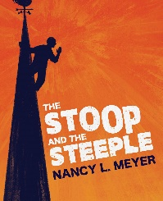  Cover for The Stoop And The Steeple | DOWNLOAD FULL RESOLUTION HERE:  https://nancylmeyer.com/wp-content/uploads/2024/08/The-Stoop-And-the-Steeple-Nancy-L-Meyer-Ebook-Cover.jpg
  Headshot of Nancy L. Meyer  Photo credit Sree Sripathy at Sreestudios.com. | DOWNLOAD FULL RESOLUTION HERE:  https://nancylmeyer.com/wp-content/uploads/2024/08/DSC_5841-scaled.jpg
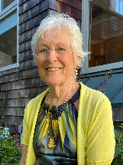  Headshot of Nancy L. Meyer  Photo credit Joss Ettrick | DOWNLOAD FULL RESOLUTION HERE:  https://nancylmeyer.com/wp-content/uploads/2024/08/Shot-5-Cropped.png

